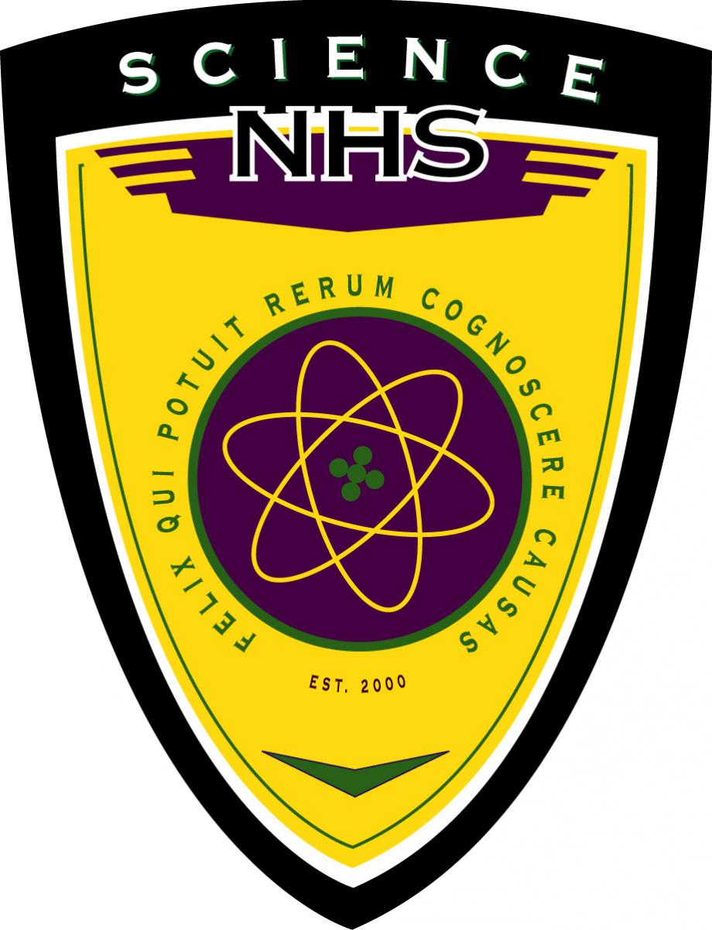
Central Magnet School
Science National Honor Society
Constitution and Bylaws

ARTICLE I
NAME AND PURPOSE

- The name of this organization shall be the Science National Honor Society of Central Magnet School.

- The purpose of this organization shall be to encourage participation in and recognition of scientific and intellectual thought, to advance the students’ knowledge of classical and modern science, to communicate with the scientific community, to aid the civic community with its comprehension of science, and to encourage students to participate in community service and, in turn, encourage a dedication to the pursuit of scientific knowledge that benefits all mankind.

- The SNHS – Central Magnet School shall be considered a non-profit organization under 501c3, as per school policy/financial standing.

- The Central Magnet School and the SNHS shall be a scholarship-granting body.

ARTICLE II
THE PRINCIPAL

- The Principal of a school shall reserve the right to approve all activities and decisions of the chapter.

- The Principal shall appoint annually a chapter advisor(s), who may serve consecutive terms.

ARTICLE III
THE CHAPTER ADVISOR(S)

- The chapter advisor(s) shall be responsible for the direct, daily supervision of the chapter, and act as a liaison between faculty, administration, students, and community.

- The chapter advisor(s) shall maintain files on membership, chapter history,
activities, and financial transactions. The chapter advisor(s) shall send an annual report to the national office.

- The chapter advisor(s) shall frequently review each member for compliance with SNHS standards, obligations, and ideals.

- The chapter advisor(s) shall help the chapter officers understand and carry out their duties.

ARTICLE IV
MEMBERSHIP

- Membership is an honor bestowed upon a student.

- A member must be in the last two years of secondary school education.

- A member must have an overall 3.5 GPA

- A member must have taken at least one Advanced Honors science class prior to the eleventh grade year. A member must be enrolled in at least one Dual Enrollment or AP science class during or prior to the twelfth grade year.

- A member must have a 3.75 Science GPA.

- A student who transfers to Central Magnet School in their junior year must complete one academic year at Central Magnet School to be considered for membership.

- A member must maintain behavior that is acceptable to the guidelines of their educational institution.

- All members must attend one local chapter officer’s lecture annually.

- Regular members may give a lecture with the chapter advisor’s approval.

ARTICLE V
SELECTION OF MEMBERS

- Candidates may be selected in any manner deemed reasonable and fair by the Principal of the school.

- Candidates may only be accepted upon adherence to the policies of membership outlined in this constitution and the club bylaws.

- Prior to selection, the following shall occur:
  - Students’ academic records shall be reviewed to determine scholastic eligibility.
  - Students who are eligible scholastically (“candidates”) shall be notified and asked to complete and submit the Student Application Form for further consideration.
  - The advisor (s) shall be requested to evaluate the candidates determined to be scholastically eligible and willing to participate in chapter functions.
  - The advisor(s) shall review the Student Application in order to determine membership.

- There shall be an induction ceremony held annually.

- Applicants shall be notified of their member status at least two weeks prior to the planned date of the induction ceremony.

- Once selected and registered, all members are expected to maintain the standards by which they were selected and maintain all obligations of membership.

- An active member of the Science National Honor Society who transfers from this school will be given a letter indicating the status of their membership, signed by the chapter advisor.

- An active member of the Science National Honor Society who transfers to this school will be accepted for membership in this chapter when proof of membership is provided. The advisor(s) shall grant to the transferring member one quarter to attain the membership requirements and, thereafter, this member must maintain those requirements for this chapter in order to retain their membership.

ARTICLE VI
MEMBERS’ DUTIES

- Membership dues will be a one-time fee of $25.00, which includes the member's graduation cord and official SNHS membership pin.

- Members shall attend 80% of all regular meetings.

- Members shall attend at least two lectures by an officer or guest speaker per school year.

- Members will earn a minimum of ten hours per year of club-related community service deemed appropriate by chapter advisors.

- Every member must participate in the at least one SNHS service project

ARTICLE VII
DISCIPLINE AND DISMISSAL

- A student may be dismissed if they violate the standards, obligations, or ideals of the Science National Honor Society. This includes violation of grade or behavioral requirements as outlined in Article VII, Sections 2 through 8.

- Any member who falls below the standards of scholarship and fails to maintain the other requirements of membership may be considered for dismissal from the Central Magnet High School Science National Honor Society. A member of the Science National Honor Society is expected to maintain their academic standing and take an active role in service and scientific leadership to their school and community.

- If a member’s cumulative GPA falls below the standard in effect when they were selected, they will be given a written warning and one semester for improvement. If the cumulative GPA remains below standard at the end of the warning period, the student will be subject to further disciplinary action by the advisor(s), which may include consideration of dismissal from the chapter.

- If a member fails to perform any of the published obligations of membership, they will be given a written warning and a time period for improvement (nine weeks). If the obligation remains unmet at the end of the warning period, the student will be subject to further disciplinary action by the advisor(s) which may include dismissal from the chapter.

- Violation of the law will result in dismissal of a member. These violations include, but are not limited to stealing; destruction of property; cheating; truancy; or possession, selling or being under the influence of drugs or alcohol at school or school-related activities. Offenders of the behavioral expectations as stated in the Student Handbook will receive a warning. Academic probation or suspension will result in dismissal from the chapter.

- In all cases of pending dismissal:
  - The member will receive written notification indicating the reason for possible dismissal from the advisor. The member and advisor will discuss the written notification in a conference. Situations that involve flagrant violation of school rules or the law can warrant disciplinary action without a written warning, although a conference must still be held.
  - The member will be given the opportunity to respond to the charge against them at the conference. The advisor has the right to dismiss any student from the Science National Honor Society for misconduct or failure to maintain society requirements.
  - Dismissed members must surrender any membership emblems to the advisor.
  - When a student is dismissed or resigns, they are no longer a member and may not be reconsidered for membership in the Science National Honor Society.

- Dismissal is approved and carried out by the chapter advisor(s). In lieu of dismissal, the advisor(s) may impose disciplinary sanctions upon a member as deemed appropriate.

- Upon dismissal, the student is divested of all benefits of membership.

- A student may appeal dismissal by submitting a written request to the Principal.

ARTICLE VIII
CHAPTER OFFICERS

- The officers of the chapter, their duties, and the method of their election shall be determined by the advisor(s) as described in the chapter bylaws.

- All chapter officers are obligated to the duty of presenting or organizing one brief scientific lecture per academic year. The lecture shall be ten to fifteen minutes in length and may be given during a regular chapter meeting or in a special ceremony.

- The local chapter officers shall have general supervision of the affairs of the chapter as overseen by the chapter advisor(s). The officers shall meet regularly, make recommendations to the chapter, and perform all duties named in the chapter bylaws.

- The officers of the chapter shall be elected by the members of the chapter. Eligibility to hold office will be determined by the evaluation of the officer’s application form and/or teacher recommendation by the chapter advisor(s) prior to elections.

- There shall be no limit to the number of nominated candidates running for each officer position

- Names of SNHS candidates will be recorded on official online ballot forms. Each SNHS member shall have one vote for each position.

- Officer terms will last roughly one year.

- All returning active members are eligible to run for a position as an officer.

- The officers of the chapter shall be president, vice president, secretary and treasurer.

- Chapter officers shall fulfill the following duties:
  - The president must prepare the agenda for all the meetings and confirm it with the advisor(s) one week prior to the meeting (with the exception of the emergency meetings). The president must represent the chapter at school and public functions, meet regularly with the chapter advisor(s) to discuss the progress of ongoing projects, coordinate the major science project(s) of the year (with the help of a specific, selected team), research and deliver or coordinate one scientific lecture (10 minutes in duration) during a regular meeting, write and deliver a speech on Goals and Achievements of the SNHS during induction ceremonies, and update the Science National Honor Society course on Moodle.

  - The vice president shall preside in the absence of the president and assist the president in maintaining order at chapter meetings. The vice-president shall also keep a record of members’ contributions to scientific leadership and service acting as a coordinator of the activities related with speakers, specific competition projects, field trips, etc. The vice-president will act as a sort of logistic coordinator and will be in charge of itinerary, transportation, etc. for SNHS projects and/or activities, plan and preside at the induction ceremony, research and deliver or coordinate at least one scientific lecture (10 minutes in duration) during a regular meeting, and serve as president if the president is removed from office or resigns.

  - The secretary should keep accurate and complete minutes of all general and executive meetings, keep accurate and complete attendance records of all the meetings, keep a proper file of all incoming and outgoing correspondence, assist the chapter advisor(s) with all official correspondence, prepare any chapter report, research and deliver or coordinate a scientific lecture ( 10 minutes in duration) during a regular meeting, work with the vice-president to help in the coordination of all the community service activities, keep a record of the service hours completed by the members and report deficiencies to the chapter advisor, keep updated rosters of all current chapter members including addresses, cell phone numbers and e-mail addresses and keep and update calendars of all chapter events for the school year. The secretary shall prepare any announcements (paper, board, LTV, etc.) that concerns full chapter meetings or chapter activities, record activities of the chapter through photographs, videos, etc. and provide the information/material to the president in order to update the chapter’s webpage.

  - The Treasurer shall keep the record of chapter expenses, dues and all other financial transactions of the chapter. The treasurer should chair and create/prepare different fund raising activities for the chapter, organize different fundraising committees, assist the chapter advisor(s) in preparing a statement of estimated receipts and expenditures for the school year, report on the financial status of the chapter at each SNHS meeting, and research and deliver or coordinate a scientific lecture (10 minutes in duration) during a regular meeting.

- Every officer should maintain a record of actions taken during their tenure to be passed on to the respective officer elected for the next school year.

- The officers shall abide by this Constitution, the Central Magnet's mission statement, the SNHS standards, obligations and ideals.

ARTICLE IX
MEETINGS

- Each chapter shall have regular meetings during the school year on days
designated by the officers and in accordance with school policy and regulations.

- This chapter shall conduct its meetings following acceptable rules of conduct.

- All chapter members are expected to attend 80% of all regularly scheduled chapter meetings.

- The president may call emergency meetings, if approved by the officers.

ARTICLE X
CHAPTER ACTIVITIES

- Each chapter shall determine two or more projects per year.

- All members shall participate in one or more of the chapter’s projects per year.

- The purpose of the projects shall be to encourage scientific and intellectual
thought, to further the knowledge of science in school and community, and to volunteer in the surrounding community.

- Chapters shall also attempt to bring speakers from the scientific community into the school to the extent to which their resources and location allow.

- The projects shall have the support of the administration and the faculty; be appropriate and educationally defensible; and be well planned, organized and executed.

- The chapter shall publicize its projects in a positive manner.

ARTICLE XI
OFFICIAL INSIGNIA AND MOTTO

- This organization shall have an official emblem selected by the National Board of Directors.

- The distribution of the emblem and the rules for its use shall be under the
exclusive control of the Science National Honor Society’s National Board of Directors.

- Each active graduate or honorary member shall be entitled to wear this
emblem.

- Chapter members who are seniors in good standing shall be granted the privilege of wearing the official SNHS honor cord at graduation.

- Any member who resigns or is dismissed shall return the emblem to the chapter advisor(s).

ARTICLE XII
POWERS

- The chapter advisor(s) is given the authority to supervise the administration of chapter activities, as delegated by the Principal.

- The Principal shall reserve the right to approve all activities and decisions of the chapter.

- These bylaws are designed to amplify provisions of the national constitution and cannot contradict any components thereof. The chapter is obligated to adhere to the provisions of the national constitution in all activities it undertakes.

ARTICLE XIII
AMENDMENTS

- Chapter bylaws may be amended by the advisor(s) at any time as deemed fit and necessary.

- When amendments are to be made by the full chapter, these bylaws may be amended by a two-thirds vote of the chapter, provided notice of the proposed amendment has been given to members at least one month prior to the vote. The exceptions are Articles IV, V, and VI which are developed by the advisor with the approval of the Principal.

- Bylaws and amendments must be consistent with the constitution of the Science National Honor Society and the Central Magnet mission statement.

